
Name : Ibrahim Haroon
System ID : NUML -S23-55287
Semester : 5
Session : spring 2023
Course : Software construction and development
Title : Project
Instructor : Ms. Aroosa Yaqoob

Title : Online book shopping system

Introduction :
- Ibrahim’s Online Book Shop is a simple and colorful website for buying books online.Users can search for books, check their stock, and view book images in a gallery.They can also add books to the cart and proceed to checkout easily.The payment option is included to complete the purchase securely.The layout is clean and each part is divided into separate sections.]The buttons and forms are styled to look attractive and easy to use.The project uses HTML and CSS in a single file to keep things simple.It is designed to be smooth, responsive, and beginner-friendly for users.

- The project have been made by keeping in mind all the good coding regulations and modularization .

- It gives users an easy and wonderful experience to shop online as it is smart and hassle free.

Components involved :
- Customer: Initiates and interacts with the checkout process.
- Shopping Cart: Represents items selected for checkout.
- Inventory Service: Checks availability of items.
- Order Service: Manages order creation and processing.
- Payment Service: Handles the financial transaction.

Scope :
- Smooth shopping experience
- Easy payment processing
- Customer gets notified about failure

Requirements of my project

•User Checkout Process
System must allow the customer to initiate a checkout operation from the shopping cart.

•Order and Cart Validation
System must validate cart items before placing an order.
Must prepare and structure the order details (items, quantities, etc.).

•Inventory Check
System must communicate with the Inventory Service to:
•Check the availability of each cart item.
•Confirm item stock before proceeding.

•Order Creation
Upon valid stock, system must generate a new order object.
Must add cart items to the order.

•Payment Processing
System must integrate with the Payment Service.
Must process payment after the order is created.

•Order Confirmation / Failure Handling
If stock and payment are valid → return order confirmation to customer.
If stock unavailable or payment fails → return error/failure response

Use case diagram :

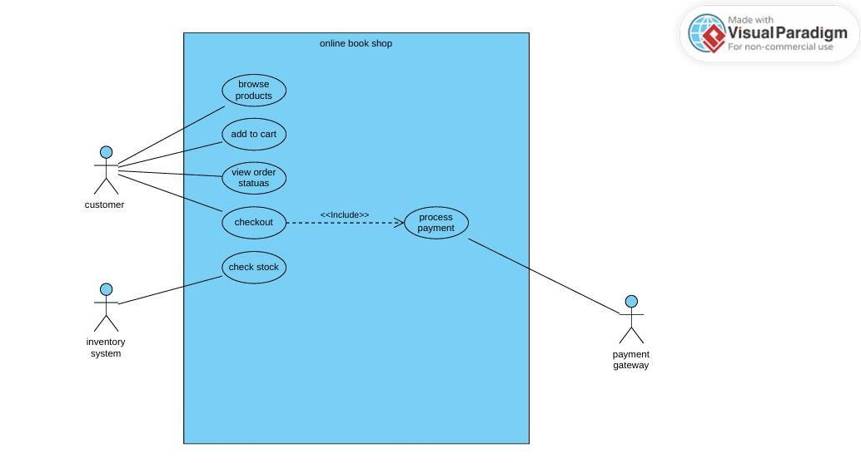

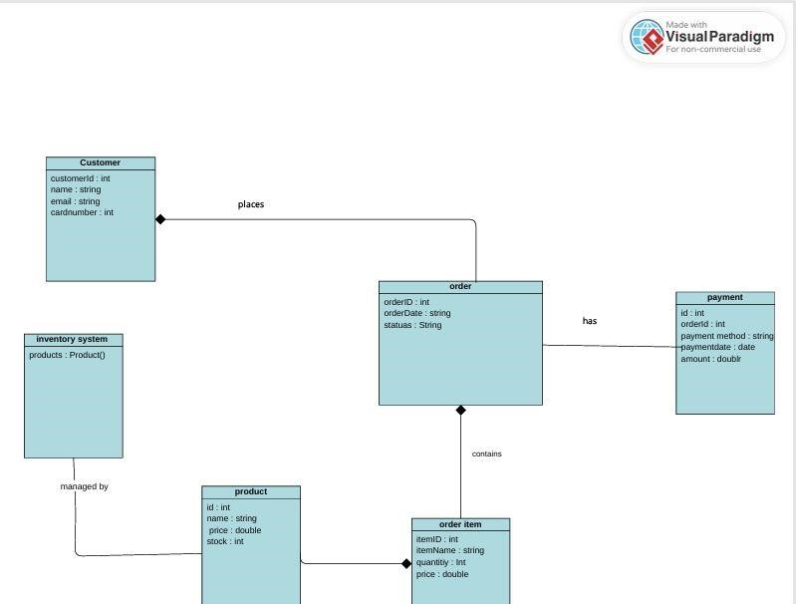
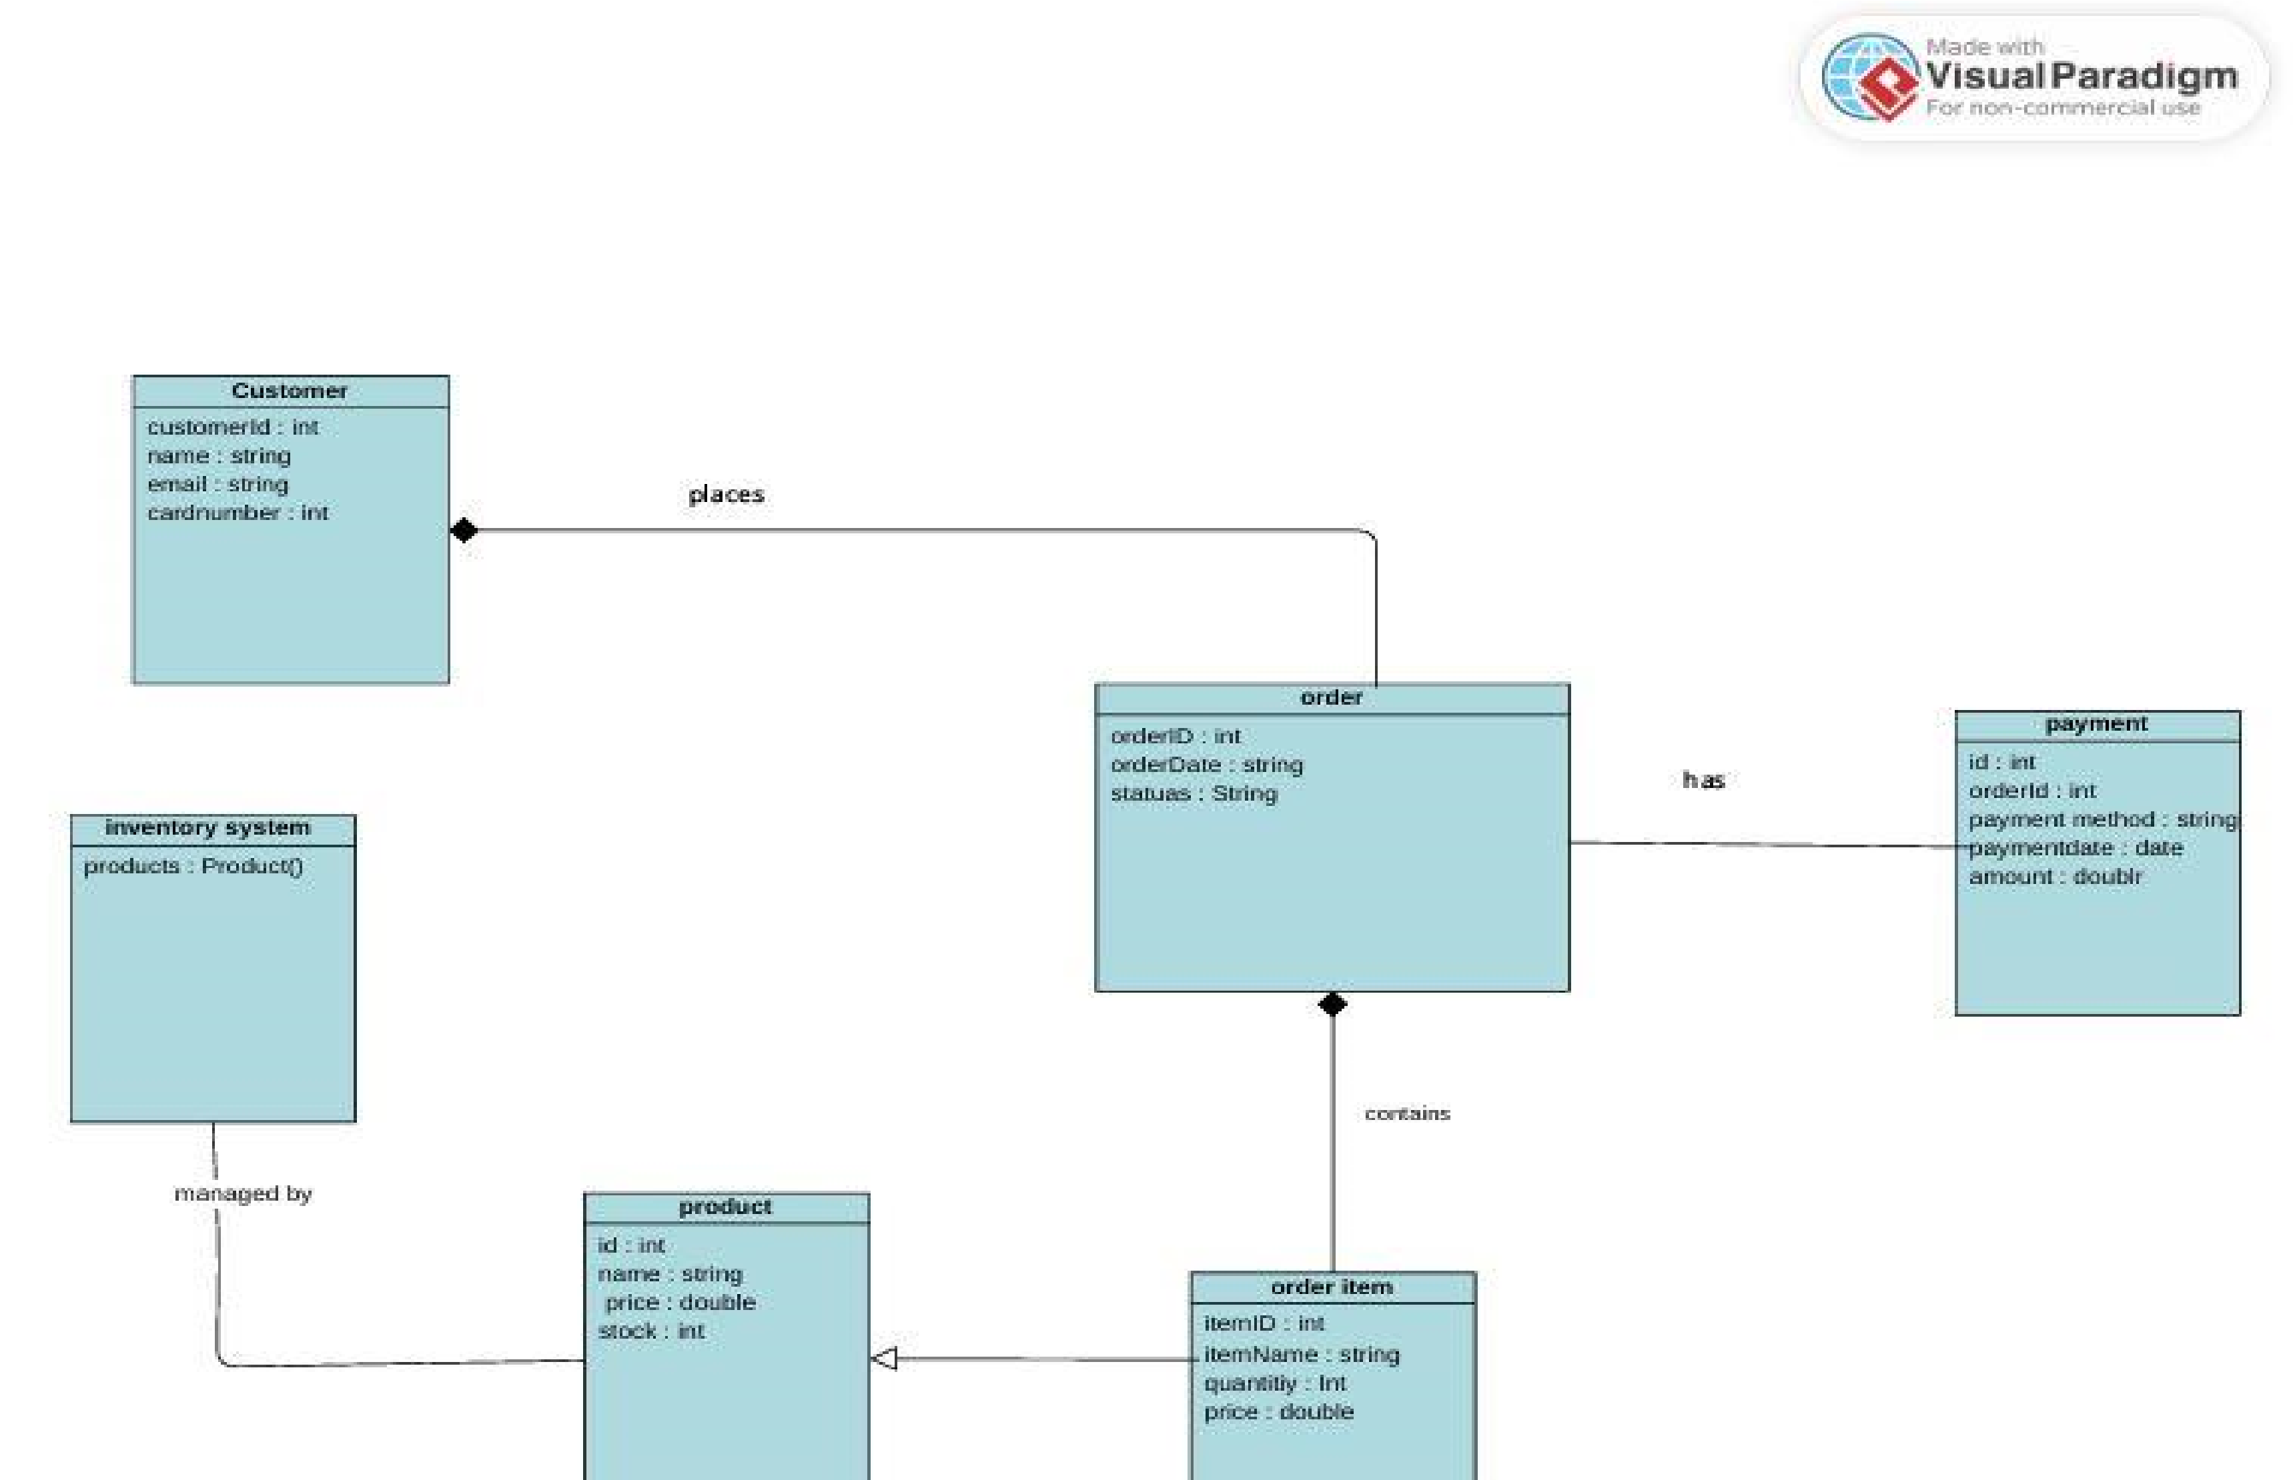
Class diagram :

Sequecnce diagram :

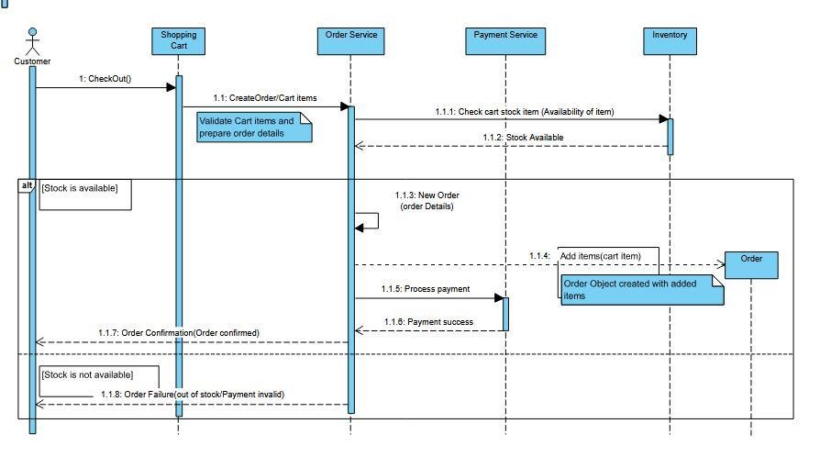

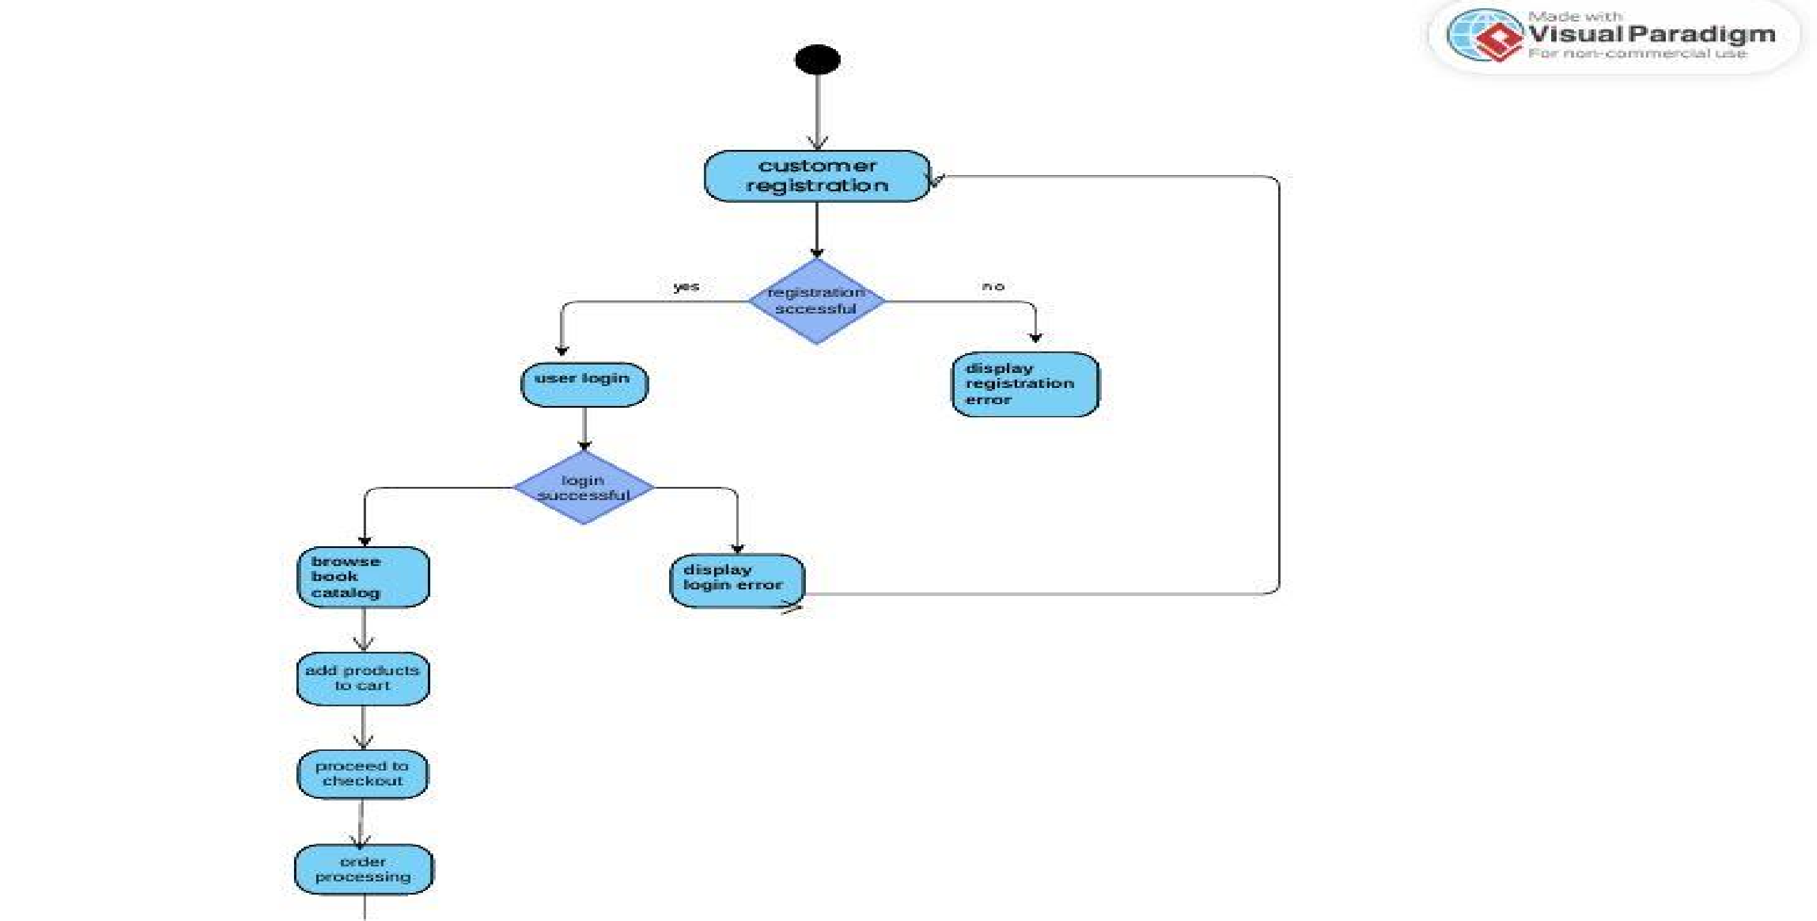
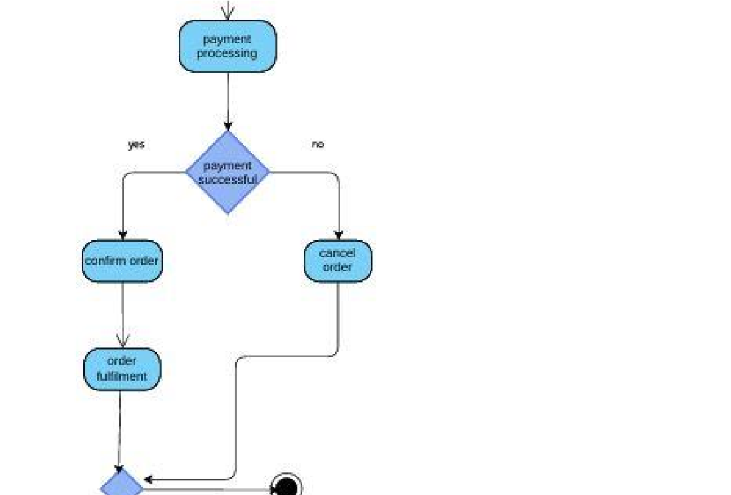
Activitry diagram :

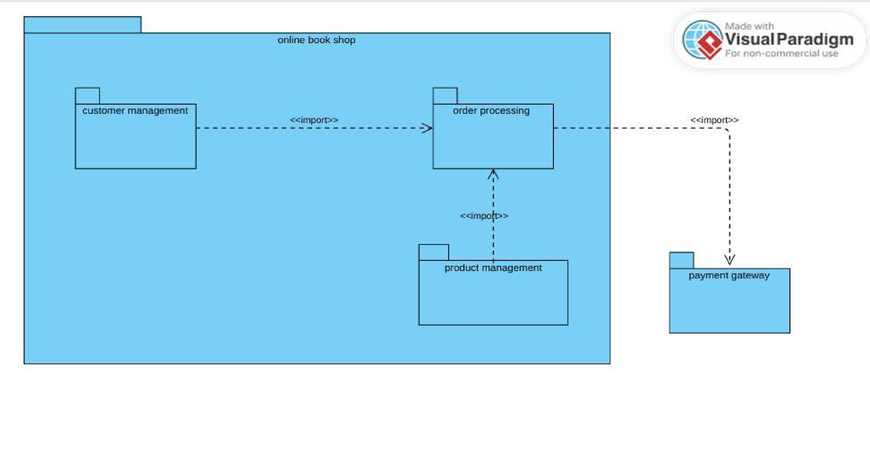
Package diagram :

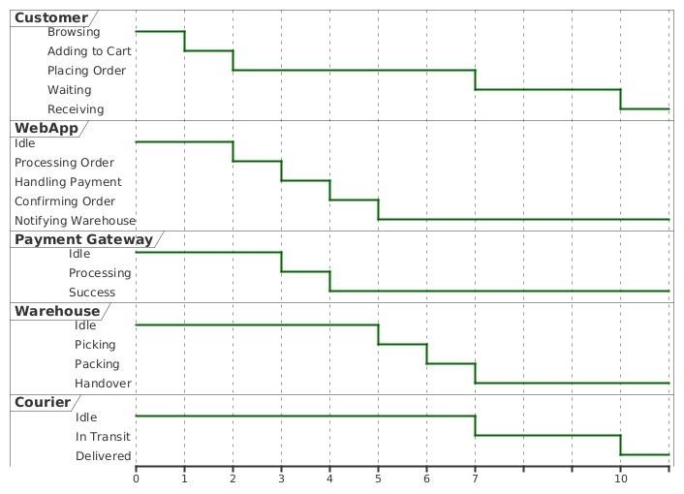
Timing diagram :

Rough code of my project :

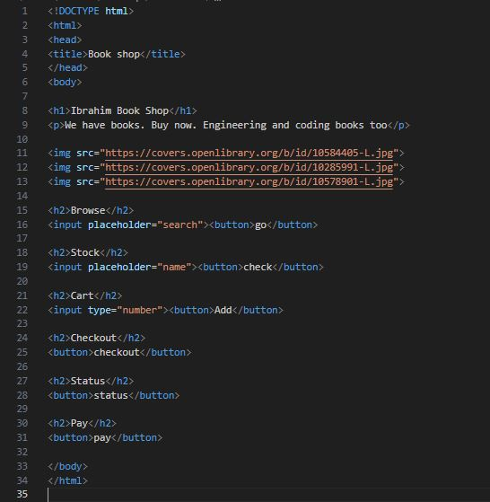

Reason why is this code bad ?

- No spacing
- No styling or messy inline styles
- No structure
- Poor readability
- Unclear naming
- Buttons and inputs are unaligned
- No layout or color
- No commenting

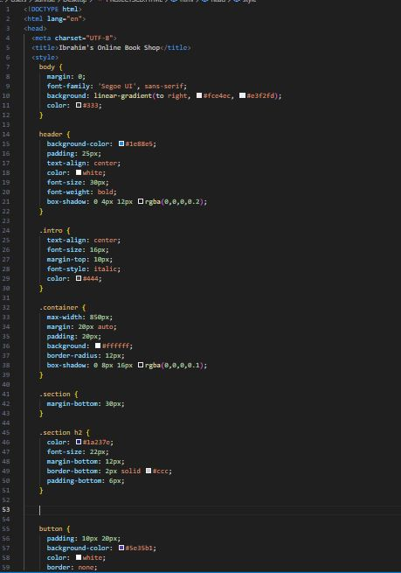
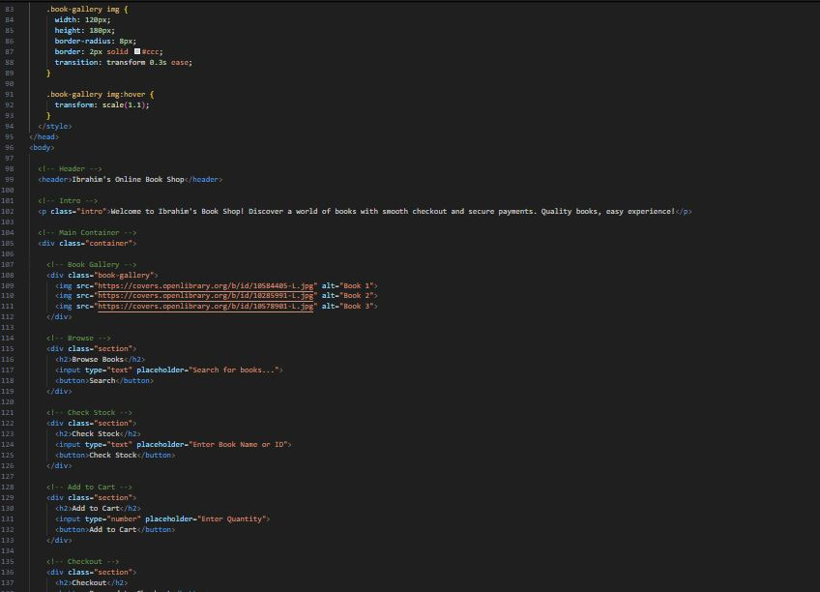
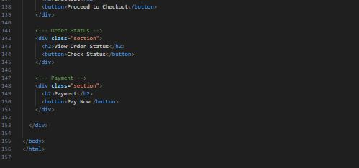
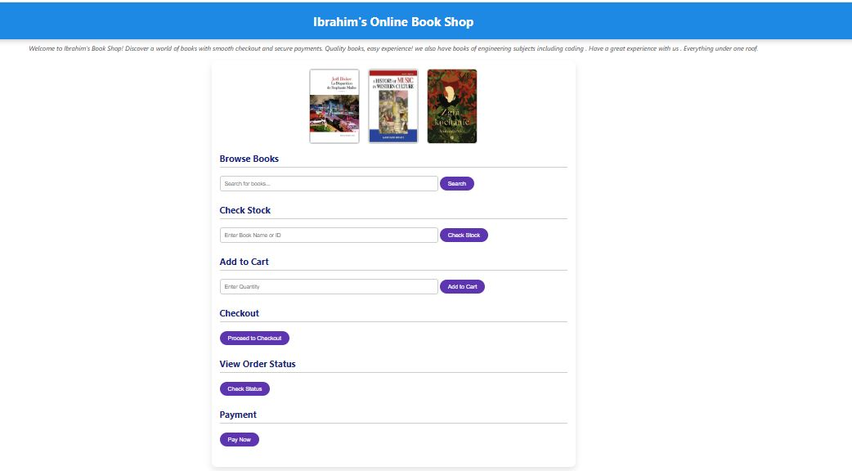
How did I Follow Modularity in my project
I have used fololwing :
Module | Purpose
header | Displays the main title of the site
.intro | Introduction text about the shop
.book-gallery | Dedicated section for showing book images
.section (x6) | Each major function is isolated (browse, stock check, cart, etc.)
Separate HTML & CSS blocks | Structure and styling are cleanly divided

How did I followed Good Code Practices
I have used following practices :
1-Meaningful naming
2-Consistent structure
3-Clean formatting
4-Commenting
Thankyou

